Perceptron Branch Predictor for PicoRV32-based SoC
Arthur Kim, Derek Kropp, Chris Rumsey
Department of Electrical and Computer Engineering, University of Arizona, Tucson, AZ

Abstract
This work demonstrates the extension and physical implementation of a RISC-V based SoC built around the PicoRV32 CPU^{[1]} using an open-source RTL-to-GDSII workflow. The compact PicoRV32 core was expanded with two major additions: a custom perceptron-inspired branch predictor and an integrated 2 KB SRAM macro. A complete design flow was implemented locally using SiliconCompiler^{[2]}, Yosys, OpenROAD^{[8]}, KLayout^{[7]}, and the Skywater130 PDK. The final layout successfully demonstrates the incorporation of custom branch prediction logic and SRAM hard macro integration through generated GDSII layout visualizations, build reports, and physical implementation metrics.

Introduction
ASIC tools make it possible to evaluate a digital design beyond RTL simulation by taking it through synthesis, floorplanning, placement, routing, and GDSII generation. This project uses an open-source implementation of this workflow to extend the compact PicoRV32 RISC-V core into a small SoC-style design using the Skywater130 PDK.
The baseline CPU was expanded with a custom perceptron-inspired branch predictor and a 2 KB Sky130 SRAM macro. The branch predictor added synthesized standard-cell logic and registers, while the SRAM introduced a fixed macro that constrained placement and routing around a physical obstacle. Together, these extensions demonstrate both architectural modification and physical macro integration in the RTL-to-GDSII flow.
The goal of this work was to demonstrate that these extensions could be incorporated into a complete physical implementation rather than only simulated at the RTL level. The final design was implemented locally using SiliconCompiler, Yosys, OpenROAD, and KLayout, producing layout visualizations, build reports, and GDSII output that verify successful integration of the custom logic and SRAM macro.

System Design & Architecture
The core of the SoC is the PicoRV32 RISC-V CPU, which provides the base processor core and memory-interface logic. The top-level wrapper extends this core with the two additional hardware blocks.
The branch predictor (BP) is intended to improve instruction flow efficiency by predicting whether a conditional branch will be taken before the actual branch outcome is fully resolved. The BP design implemented in this project uses a 3-bit global history register and a four-entry perceptron table. Each 32-bit table entry stores four signed 8-bit values: one bias term and three branch-history weights. The program counter (PC) is hashed into a 2-bit table index using an XOR of selected PC bits, selecting one perceptron entry. A prediction score is then computed as score = bias + ω₀h₀ + ω₁h₁ ₊ ω₂h₂, where each history bit (h_{i}) is encoded as +1 or –1. A nonnegative score predicts the branch as taken, while a negative score predicts not taken. When a prediction has been deemed correct or incorrect, this outcome is fed back to update global history and adjust the selected weights. This concept was inspired by Jiménez and Lin’s approach^{[5]}.
The SRAM block provides a fixed on-chip memory structure implemented as a Sky130 macro. Unlike the branch predictor, which is synthesized from RTL into standard-cell logic, the SRAM is inserted through predefined physical and timing views.

Methodology
SiliconCompiler was used to manage the RTL-to-GDSII workflow. The flow was run locally using Yosys for RTL synthesis, OpenROAD for floorplanning, placement, CTS, and routing, KLayout for GDSII inspection, and the Skywater130 standard-cell library and PDK.
Phase 1: Building the PicoRV32 Core — The baseline PicoRV32 Verilog from GitHub was incorporated as the processor core and connected through a top-level wrapper. This baseline established the RTL-to-GDSII flow before additional hardware was integrated.
Phase 2: Adding the Perceptron Branch Predictor — To demonstrate architectural extension of the PicoRV32 CPU, a perceptron-inspired branch predictor was implemented in Verilog as neural_bht.v and instantiated in the top-level module picorv32_bp_top.v. The predictor was implemented as a register-based structure to preserve the prediction concept while reducing area, fanout, and routing pressure.
Phase 3: Integrating the SRAM Macro — A 2 KB Sky130 SRAM hard macro was added using a Verilog black-box model, LEF physical abstract, Liberty timing model, and GDSII layout view. The SRAM macro was registered as an ASIC library in the SiliconCompiler build script so OpenROAD could use its physical size, pins, and routing blockages during placement and routing.
At each phase, build logs, generated metrics, and GDSII inspection of die size, placement density, and timing constraints were used to verify the physical implementation.

Implementation and Results
The final implementation successfully completed the local RTL-to-GDSII flow and generated a routed layout containing the PicoRV32 CPU, custom branch predictor logic, and one integrated Sky130 SRAM macro. As shown in Fig. 1, the completed run reached GDSII and final view generation with zero flow errors. Table I shows key metrics at each stage of the build, while Table II shows final implementation metrics. The final design used a 1000×1000 µm die, which was occupied by a SRAM macro of 284,538 μm², and standard-cell logic of 101,723 μm². Utilization percentage and cell count can also be found in this table.
Fig. 2 shows the PNG output by SiliconCompiler of the GDSII result. For a more useful view, KLayout^{[7]} was used to produce Fig. 3 and Fig. 4, which show the complete SoC and a zoomed view of the SRAM macro.

Analysis and Future Work
Integration of the BP with the CPU and SRAM elements of the SoC demonstrated the capability of this workflow to handle complex integration challenges. However, it also demonstrated that increasing complexity comes with design and tool limitations. The decrease in maximum frequency to 15.055 MHz shows the limitation of the Skywater130 PDK for use in design of increasing complexity. The post-CTS timing repair also had to be removed from the final run due to local memory bandwidth and server load when trying to meet maximum skew. Clearly, the reduction of frequency by over 50% dwarfs any performance improvements from BP, and the inability to verify timing repair places a huge question mark on performance.
This project demonstrates that custom synthesized branch prediction logic can be integrated alongside rigid physical SRAM macros within the Skywater130 PDK. Future work will prioritize running the flow with higher memory capacity to enable the bypassed timing repair steps, ideally resolving hold violations and producing a timing-clean signoff layout. Additionally, expansion of the branch predictor's history register depth and utilizing SRAM as a primary instruction or data cache would help to improve core IPC.

References
[1] YosysHQ, "PicoRV32: A Size-Optimized RISC-V CPU Core", GitHub Repository, https://github.com/YosysHQ/picorv32
[2] SiliconCompiler Documentation, https://docs.siliconcompiler.com
[3] ECE 407/507 Project Description, University of Arizona, 2025.
[4] RISC-V Foundation, "The RISC-V Instruction Set Manual", https://riscv.org.
[5] Daniel A. Jiménez and Calvin Lin, “Dynamic Branch Prediction with Perceptrons,” in Proceedings of the 7th International Symposium on High-Performance Computer Architecture (HPCA), 2001, pp. 197–206.
[6] M. Guthaus et al., “OpenRAM,” GitHub repository. [Online]. Available: https://github.com/VLSIDA/OpenRAM/tree/stable.
[7] M. M. (Matthias) Köfferlein, “KLayout Layout Viewer and Editor,” [Online]. Available: https://www.klayout.de/intro.html.
[8] The OpenROAD Project, “OpenROAD,” GitHub repository. [Online]. Available: https://github.com/The-OpenROAD-Project/OpenROAD
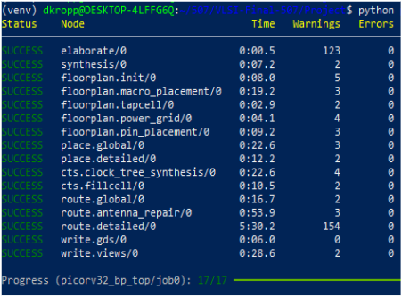  Fig. 1. Successful run log of the complete RTL-to-GDS-II design flow implementing branch prediction and SRAM. | Cell Area (um²) Utilization (%) Peak Power (mw) Setup Slack (ns) fmax (MHz) Total Time_ (s)  syn0 373,993 - - - - 7.785  floorplan. init0 372,236 38.906 2.102 20.55 - 15.822  floorplan.pin_ placement0 383,284 40.061 - 7.142 - 42.052  place. global0 383,284 40.061 2.157 7.053 14.717 01:13.768  place. detailed0 383,284 40.061 2.156 7.517 14.819 01:25.950  cts.clock_tree_ synthesis0 386,088 40.354 2.643 7.570 14.830 01:48.506  386,088 40.354 2.915 15.77 11.016 02:15.699  route.detailed0 386,261 40.372 2.550 16.84 17.195 08:39.755  write.views0 386,261 40.372 2.663 8.578 15.055 09:14.321  Table I. Monte Carlo Analyses each stage in the RTL-to-GDS-II flow.
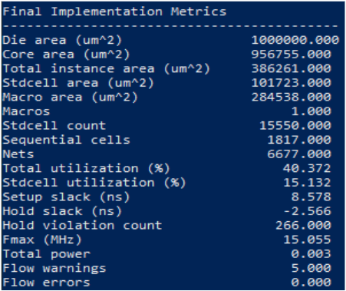  Table II. Final Implementation Metrics. | 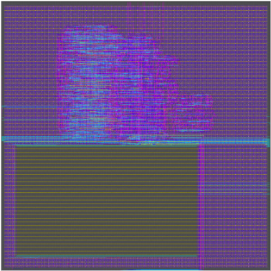  Fig. 2. Final GDS layout output from Silicon Compiler with SRAM  location shown as black box.
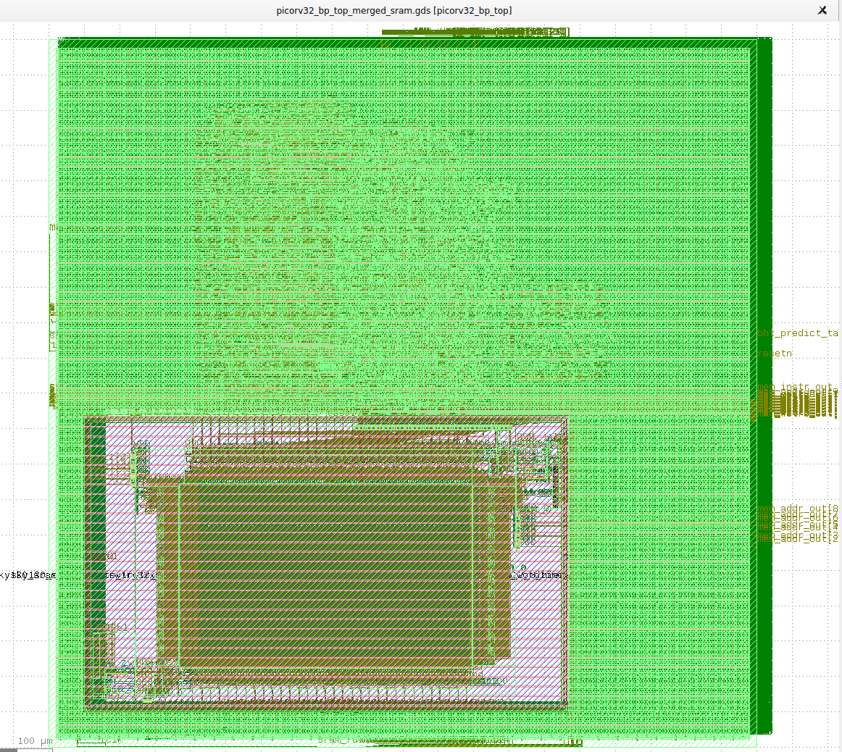  Fig. 3. Overall Layout from Klayout, showing SRAM internals and overall routing and design | 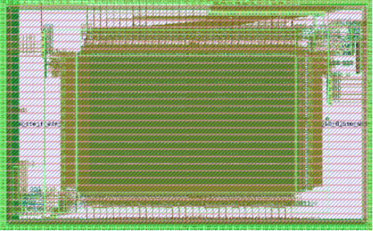  Fig. 4 Detailed section of Klayout final design, showing internal placement of the SRAM components.

